**1 Introduction**

**1.1 Goals and governance of the corporation**

**Investment decisions** (capital expenditure CAPEX decisions) **& financing decisions**

* Investment decision = purchase of real assets: to invest tangible/intangible assets (e.g. R&D)
* Financing decision = sale of financial assets: decide sources and amount of financing

**Real assets v.s. financial assets**

* Real assets: used to produce goods and services
* Financial assets: financial claims to the income generated by the firm's real assets（shareholders 因为投资了real assets，所以他们有claim去索要这些real assets产生的钱）
  + Equity financing
  + Debt financing
  + Capital structure decision

[**Securities:** financial assets that can be purchased and traded by investors in public markets. (bank loan is not except resell to public investors)]

**Corporation (private + public)**

**Definition:** distinct, permanent legal entity owned by shareholders

* **Incorporate** means indirect ownership of real assets via financial assets (share of the new corporation)

**Business organization**

|  |  |  |
| --- | --- | --- |
| **Ownership:** |  |  |
| Sole trader | Unlimited liability | No taxes |
| Partnership | Unlimited liability | No taxes |
| Limited partnership  (Advantage of (tax + liability)) | Limited liability (LP), unlimited liability (GP) | No taxes |
| limited liability partnerships (LLP) /limited liability companies（LLC) | Limited liability for all partners | No taxes |
| **Separation of ownership and management:** |  |  |
| Professional corporation | Limited liability | Taxes, can be sued, cannot vote |

**Separation of ownership and management:**

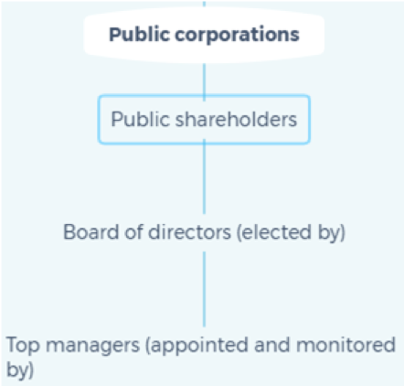

**Financial managers**

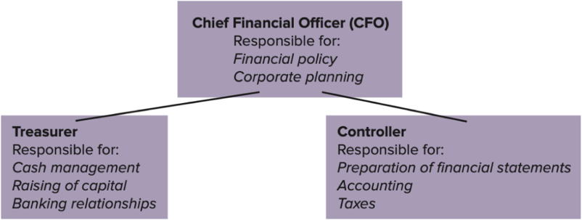

* CFO: supervises all financial functions and set financial strategy
* Treasurer: responsible for financing, cash management, relationships with banks and other financial institutions
* Controller: responsible for budgeting, accounting and taxes

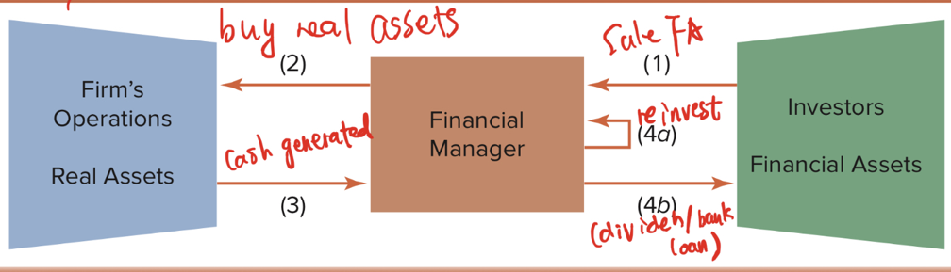**Cash flow**

**Goals of the corporation**

Shareholder wants managers to maximize the market value of the corporation (not profits, which damage long-term value)

[Market value = equity share number * equity value]

**Opportunity costs of capital / hurdle rate**

* The minimum acceptable rate of return on investment projects
* Set by the return rate for investor to invest the cash for themselves in the financial markets

**A general principle**: a corporation should direct cash to investments that *add market value*, compared with investments shareholder could make on their own. (direct to real assets, if return on real assets > return on financial assets)

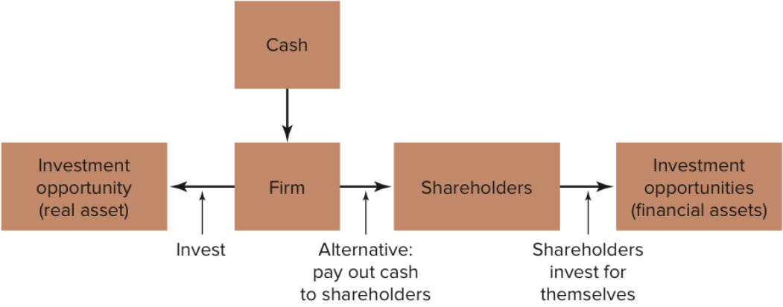

Future rate of return on investment projects will be calculated (Chapter 8,9). Opportunity cost of capital for shareholders' safe investment (debt securities) could be checked; for risky investment (e.g. stocks) has to be estimated (Chapter 11)

**Agency problems**

**Definition:** Managers (agents) make their own interest while stockholders want them to make interest for the corporation

**Agency costs:** Value lost from (agency problems + the cost of mitigating agency problems)

**Stakeholders:** people who share a pie in the corporation (e.g. workers, managers, stockholders)

**Executive compensation**

Package = a fixed base salary + annual award tied to earnings + other measures (stocks, options)

Well-designed compensation can alleviate agency problems but the not-well-designed even rewards manager when value is destroyed

**Corporate governance** (breaks down or works properly)

Good corporate governance (alleviate agency problems)

1. Well-designed management compensation packages
2. Legal requirement
   * Laws, regulation, institutions
3. Board of directors
   * Elected by shareholders, represents their interests
   * Appoint CEO/CFO
   * Approve important financial decisions
   * Passive supporters of top management
   * Independent with management
4. Activist shareholders
   * Shareholders monitor management more actively
   * **Blockholders:** own over 5% shares
   * Shareholders' leaving will drop the stock price
5. Takeovers
6. Transparent information for investors
   * Corporations can generate extra scrutiny from the falling stock price if its information (profitability, prospects) is transparent

**Ethics of maximizing value**

Ethical issues in discussions for finance

* **Short-selling:** expects securities to decrease, borrow securities, selling for cash, then buy the securities when their price is low to pay off securities
* **Corporate raiders:** buy companies, takes them apart, sell them bits > they pay for the total package
* **Tax avoidance**

**1.2 Financial markets & institutions**

**The importance of financial markets and institutions**

Businesses must go to *financial markets and institutions* for the financing they need to grow, a modern financing system will offer financing concerning the 1. company's age, 2. growth rate, and 3. the nature of the company.

**The flowing of savings to corporations**

The money that corporations invest in real assets comes **ultimately** from saving by investors.

**For small, closely held corporations:**

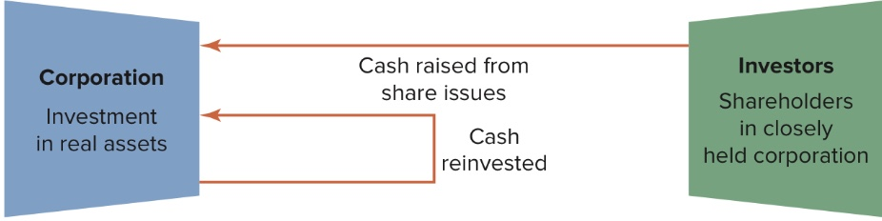

[Cash reinvested]: cash could have been paid to shareholders for their own consumption.

**For large corporations:**

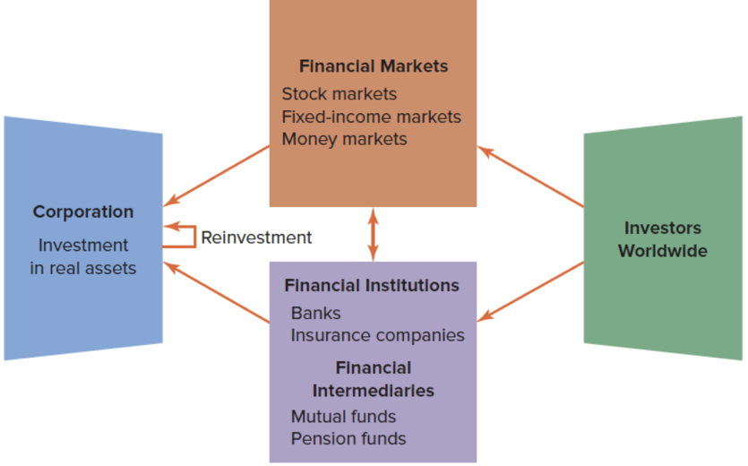

**Financial market:** where securities are issued and traded

1. [primary market]: the market for the sale of new securities by corporations.

[NYSE(New York Stock Exchange)]: a organized exchange where corporations issue shares. (where IPO occurs)

1. [secondary market]: the market in which previously issued securities are traded among investors.

1. [stock market / equity market]: stockholders own common equity of the company
2. [Fixed-income markets]: the market for debt securities

1. [Capital market]: markets for long-term debt and equity finance
2. [money market]: market for short-term financing (e.g. commercial paper, which is debt with maturity no more than 270 days)

1. The foreign exchange market

Markets for corporations engaging in international trade transferring money back and forth between *dollars and other currencies*. Trade over the counter.

[**OTC** (over the counter): non-centralized market]

1. The commodities market

Dozens of commodities exchanged in organized exchanges

1. The market for options and other derivatives

Derivatives are securities whose payoffs depend on the prices of other securities or commodities. (e.g. options: payoff depends on the IBM share on future date; future contract: payoff depends on price of commodities)

**Financial intermediary:** an organization raising money for corporations, individuals, other organizations from investors

[difference between financial intermediary & manufacturing corporations]: 1. they raise money from different ways 2. they invest that money on financial assets (corporations on real assets)

1. **Mutual fund**: investment company (no taxes, selling shares to its investors, investors pay personal tax), pools savings from investors and invests in a portfolio of securities
   * **Open-end**: issue shares and pay back share when investors enter and exit
   * **Close-end**: fixed-number of shares, and investors need to buy from others

[Pros]: low-cost diversification and professional management

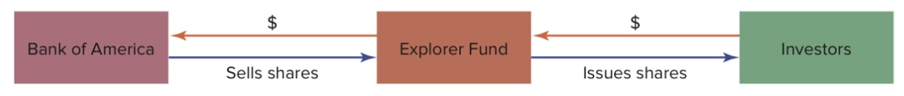

1. **Hedge fund**: private investment fund that pursues complex, high-risk investment strategies

[difference between mutual fund]: 1. restrict to knowledgeable investors 2. charge investors performance-related fees 3. manage less money but take big position and large impact.

1. **Pension fund**: a percentage of a man's paycheck is contributed to the pension fund (e.g. %5), the amount available for retirement depends = (accumulated contribution + return)

[**defined-contribution plan v.s. defined-benefit plan]:**

**DC:** investors let the employees themselves choose the strategy and they take the risk.

**DB:** the firm promises to pay employees a fixed amount of money after retirement, firms take risk.

**Financial institutions**

A financial institution not only invest in securities, but also lend money directly to individuals, businesses, other organizations

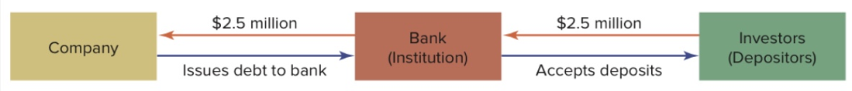

1. **Commercial banks:** provides debt financing for corporations, provides for depositors to park money safely and withdraw it as needed

[they are major sources of loan for corporations]

1. **Investment banks:** 
   * advises, assists banks to obtain finance
   * underwrite stock offerings by purchasing new shares from corporations and resell to investors
   * advice takeovers, mergers, acquisitions
   * run trading desks for foreign exchange, commodities
   * invest own money in start-ups, other ventures.

1. **Insurance companies**
   * More important than banks in financing: always make long-term loan with corporations
   * Money source: sale of insurance policies
   * Must charge enough to 1. cover selling and administrative costs 2. pay policyholders' claims 3. pay stockholders’ profit

**Functions of financing market and intermediaries**

1. **Transporting cash across time:** transport current income to future when needed (pension fund, insurance policy), (transfer money to future rainy day when needed by depositing) (transport future expenditure today when needed by loan)

1. **Risk transfer and diversification:** Financial markets and intermediaries allow investor to reduce and reallocate risk.
   * **Insurance company:** average out your risk
   * **ETFs:** exchange-traded funds are portfolio of stock which matches market indexes (which is different from closed-end funds, as CEFs are not indexes, but more complex portfolios)
   * **Commodities markets:** future contract

1. **Liquidity:** the ability to turn the investment back into cash when needed (illiquid loan to liquid deposit)
   * Deposits
   * Shares of public companies
   * Foreign exchange markets

1. **The payment mechanism**

Checking accounts, credit card, electronic transfers allow individuals and firms to send and receive quickly over long distances

1. **Information provided by financial markets**
   * Commodity prices (use it to determine whether to lock in prices)
   * Interest rate (for bond etc.)
   * Company values: stock prices sometimes summarize the situation of the company
   * Opportunity cost of capital: expected rate of return of financial assets with the same level of risk.

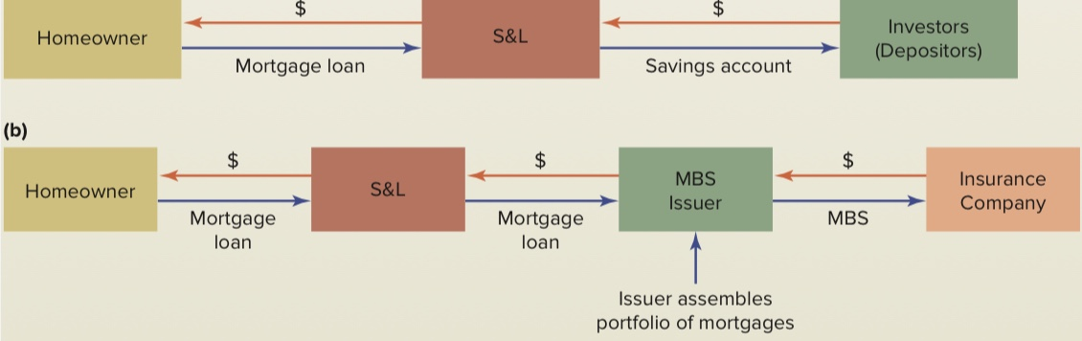**The crisis of 2007-2009**

**1.3 Accounting and finance**

**Balance sheet**

**Features:**

* Marketable securities belong to current asset
* Net assets = shareholders' equity
* Net working capital = current asset - current liability

**Common-size balance sheet:** all items are expressed as a percentage of total assets

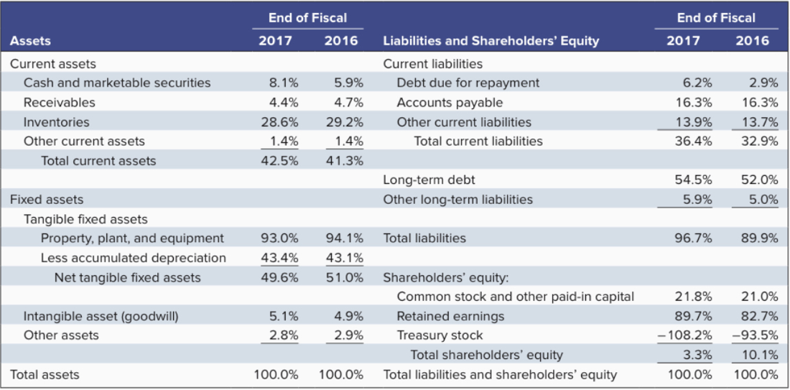

**Book value and market value**

* Book values are base on original/historical values; market values measure current values of assets and liabilities.
* Stock price = market value of shareholders' equity/the number of outstanding shares [which are stocks currently held by shareholders]

**The income statement**

**Common-size income sheet**

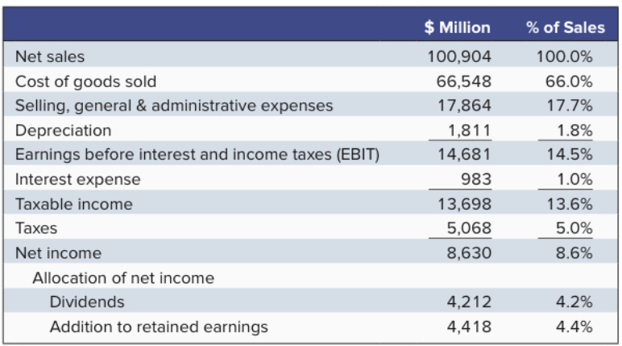

**EBIT:** earnings before interest and income taxes

**Income v.s. cash flow**

* **Depreciation:** to calculate the cash produced by the company, we need to profits (income) + *depreciation (non-cash payment)* - *the expenditure on new capital equipment (cash payment).*
* **Accrual accounting & cash accounting:** revenue, expense are recognized when sales are made, rather than when the cash outflow/inflow.

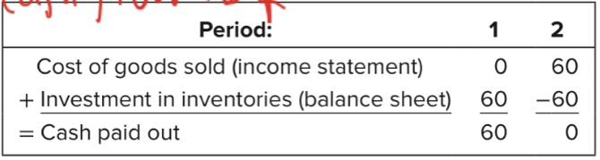

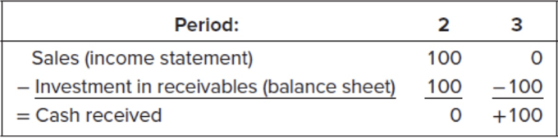

**The statement of cash flows** (cash receipt and cash payment over a period of time)

* Cash flow of operations

Net income + depreciation + total change of working capital (except cash) + stock-based compensation expense（原本算在expense里，现在也要add back回来）

* Cash flow of investment (e.g. plant and equipment)
* Cash flow of financing activities (e.g. sale of new debt or stock)

**Free cash flow (FCF):**

= interest paid to creditors + cash available for shareholders (不是指一定要分给shareholders，而是指能够分的） - cash to pay for new investment

= cash available for distribution for investors - pays for investment

**Accounting practice and malpractice**

* **Revenue recognition:** recognize sales in advance
* **Cookie-jar reserves:** use in-case reserves in bad years
* **Off-balance sheet assets and liabilities:** accounting misbehaviors

**Taxes**

**Corporate tax**

**Taxable income:** expenses, interest paid to debt holders are deductible, but dividend is not deductible.

**Personal tax**

**Marginal tax rate:** additional taxes owed per dollar of additional income

**Average tax rate:** total taxes / total income

(U.S. still taxes on investment earnings (e.g. dividend, capital gain（股票卖出和原价之间的差价所得called capital gain）))

**1.4 Measuring corporation performance**

**Financial ratios**

**Market capitalization:**

= share price * number of shares outstanding

**Performance measures**

* **Market value added $=market value-book value$**
* **Market-to-book ratio $= \frac{market value of equity}{book value of equity}$**

**[Attention]:**

1. firm repurchase will decrease the book values?（因为对firm来说，cash下降，equity下降）
2. Market value added may be large because of firm's large scale, market-to-book ratio is more revealing

**[Disadvantages of market value]:**

1. It's expectation about future performance
2. It may be affected by outer risks and noise, thus may not truly reflect management's performance
3. It can only reflect as a whole, not within the company of different departments

**Profitability measures**

* **Economics value added** (EVA/residual income)

= $profit \left(after deducting all costs, including cost of capital\right)= interest * tax + net income - cost of capital$

* Total capitalization/long-term capital = long-term debt + shareholders' equity
* Cost of capital = total capitalization * WACC
  + WACC (weighted average cost of capital): average all kinds of capital * percentage of cost of capital

* **Return on assets (ROA)**

$$= \frac{after tax operating income}{total assets}$$

* **Return on capital (ROC)**

$$= \frac{after tax operating income}{total capitalization}$$

[After tax operating income = net income + after-tax interest（因为interest不属于operating里面的]

* **Return on equity (ROE)**

$$= \frac{net income}{equity}$$

**Efficiency measures**

* **Asset turnover** (how hard the firm's assets are working)

$$=\frac{sales}{total assets }$$

* **Receivables turnover**
$$=\frac{sales}{receivables at start of year}$$

* **Average collection period** (average length of time to for customers to pay the bill) (days)

$$=\frac{receivables at start of year}{average daily sales}$$

* **Inventory turnover**
$$=\frac{cost of goods sold}{inventory at start of year}$$

* **Average Days in inventory** (sufficient inventory to maintain operation for x days) (days)

$$=\frac{inventory at the start of the year}{daily cost of goods sold}$$

* **Profit margin**
$$=\frac{net income}{sales}$$

* **Operating profit margin**

$$=\frac{after-tax operating income}{sales}$$

**Leverage measures**

* **Long-term debt ratio**

$$=\frac{long-term debt}{long-term debt+equity}$$

* **Long-term debt-equity ratio**

$$=\frac{long-term debt}{equity}$$

* **Debt-to-equity ratio**

$$=\frac{total liabilities}{equity}$$

* **Total debt ratio**

$$=\frac{total liabilties}{total assets}$$

* **Times interest earned**

$$=\frac{EBIT}{interest payments}$$

How much earnings can cover the interest (moderate as 2 or 3, higher will be considered as conservative)

* **Cash coverage ratio**

$$=\frac{EBIT+depreciation}{interest payments}$$

How much cash can cover the interest

**Liquidity measures**

* **Net working capital to assets**
$$=\frac{net working capital }{total assets}$$

* **Current ratio**
$$=\frac{current assets}{current liabilities}$$

* **Quick ratio**

$$=\frac{cash+marketable securities+receivables}{current liabilities}$$

* **Cash ratio**

$$=\frac{cash+marketable securities}{current liabilities}$$

**The Du Pont system**

**Return on assets $=\frac{after-tax operating income}{assets}$**

$$=\frac{sales}{assets}*\frac{after-tax operating income}{sales}$$

$$=asset turnover*operating profit margin$$

**2 Value**

**2.1 the time value of money**

**Compound interest, future values and present values**

* Compound interest: interest earned on interest
* Simple interest: interest only earned on original investment

* Future value (FV): the amount (original + earning interest)
* Present value (PV): how much we invest today to produce future value

* Discount cash flow (DCF): calculate PV by discounting future cash flow
* Discount rate: interest rate in used in DCF

$PV=\frac{FV after t periods}{{\left(1+r\right)}^{t}}$, **discount factor: $\frac{1}{{\left(1+r\right)}^{t}}$**

**Multiple cash flow**

* 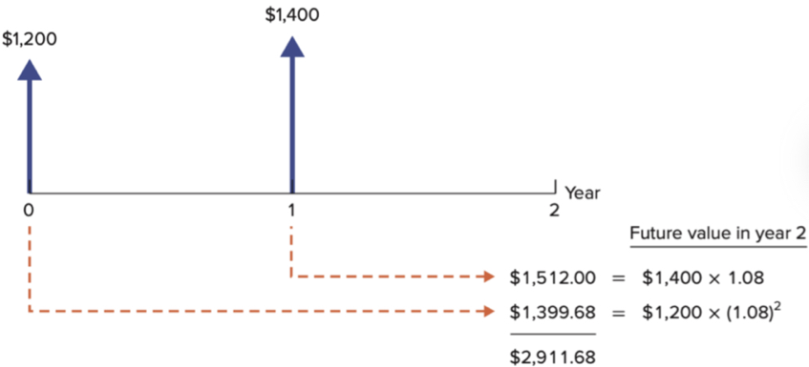**FV of multiple cash flows**
* 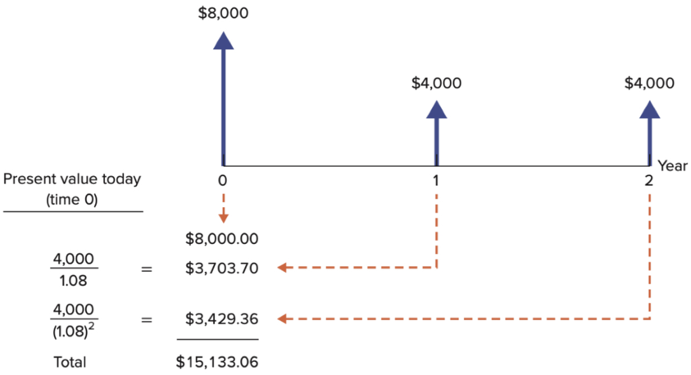**PV of multiple cash flows**

**Financial calculators**

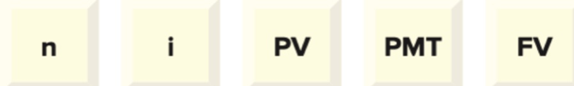

n is the number of periods

i: interest rate

PMT (payment): the amount of recurring payment

**Rule:** the fifth can be calculated if given the other known four.

**Spreadsheet**

FV = FV (i, n, pmt, PV)

PV = PV (i, n, pmt, FV)

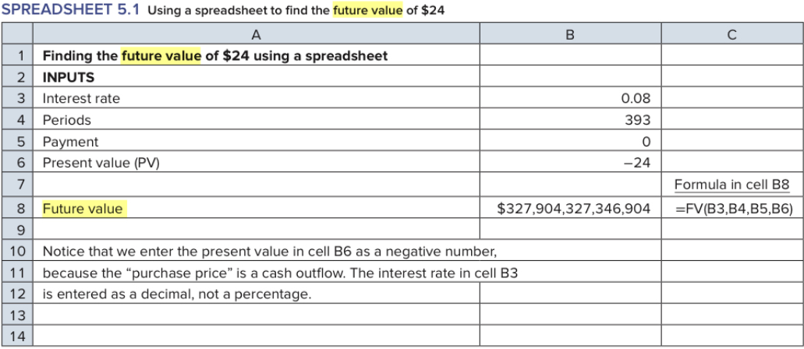

**Attention:**

* Interest rate is decimal not percentage
* Money inflow is positive, money outflow if negative

**Perpetuity and annuity**

**Perpetuity:** stream of cash payments that never ends

* Cash payments (C) = interest rate (I) * present value (PV) (original value)
* present value (PV) = Cash payments (C) / interest rate (I) = 1/r

【一次性投入，然后待在perpetuity体系里面，每年拿钱】

**Annuity:** cash flows at regular intervals with finite maturity

【每年都定期inflow/outflow钱，待在interest体系里】

1. **PV of annuity**

PV of t-year period = payment(PMT) ∗ annuity factor

**Annuity factor: $\frac{1}{r}\left(1-\frac{1}{{\left(1+r\right)}^{t}}\right)$**

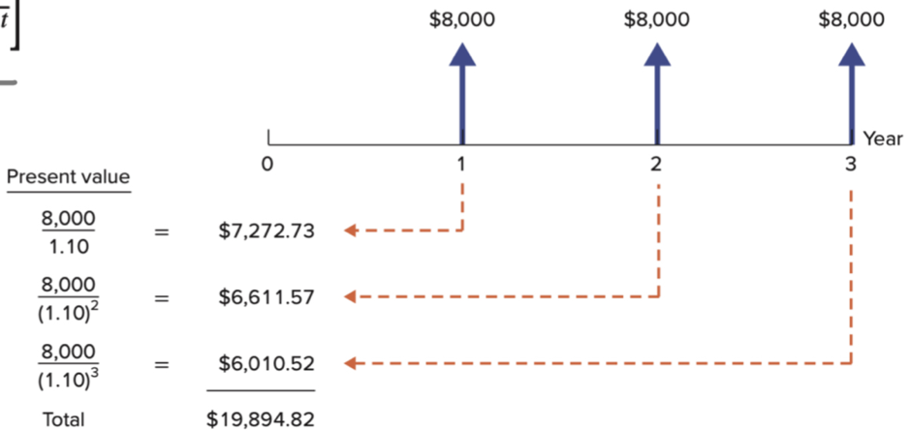

**Application**

* **Saving for retirement** (save at first, then get annually for consumption)
* **Home mortgages**

Annual payment = interest paid + amortization

(Bank first lend you money, and you repay annually afterwards)

1. **FV of annuity**

$$FV=PV*{\left(1+r\right)}^{t}=PMT*\frac{{\left(1+r\right)}^{t}-1}{r}$$

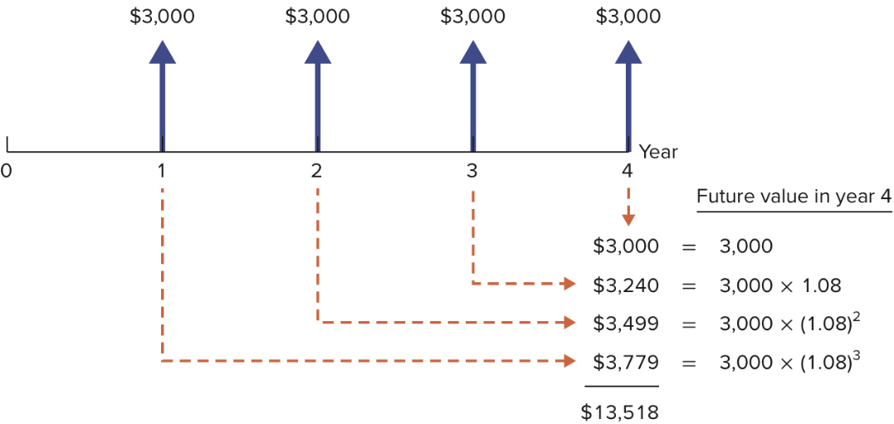

**Application**

* **Saving for retirement** (save annually and get the set total in final year)

**Annual interest rates**

**Annuity due:** stream of cash flow starting immediately

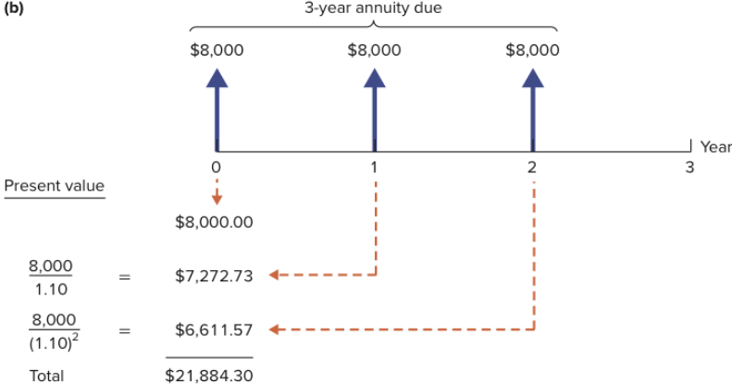

PV of annuity due = PV of ordinary annuity * (1+r)

FV of annuity due = FV of ordinary annuity * (1+r)

**Effective annual interest rate**

**Effective annual interest rates:** annualized using compound interest (because there are interest rates for days, months, years)

${\left(1+monthly rate\right)}^{12}-1$

**Annual percentage rate (APR):** annualized using simple interest

$month*monthly simple interest rate$

**Effective annual interest rate & APR**

* Effective annual interest rate = ${\left(1+\frac{APR}{m}\right)}^{m}-1$

**Inflation and the time value of money**

**Real v.s. Nominal cash flow**

**CPI** is used to measure inflation

[Nominal和Real的区别就来自于inflation的影响]

* **Nominal dollar:** actual number of dollars of the day
* **Real dollar:** amount of purchasing power

**Inflation and interest rate**

* **Nominal interest rate:** rate actual money invested grows
* **Real interest rate:** rate of purchasing power grows

$$real interest rate=\frac{1+nominal interest rate}{1+inflation rate}-1$$

$real interest rate≈nominal interest rate-inflation rate$

**Valuing real cash payments**

**Rule:**



PV = nominal dollars (future not present) / nominal interest rate = real dollars (today) / real interest rate

**2.2 valuing bonds**

**Bonds and the bond market**

**Bond/notes/debentures**

**Definition:** Security, obligate issuer to make specified payments to the bondholder

**Characteristics:**

* face value/principal/par value: payment at the maturity of bond
* Coupon: interest payment to the bondholder.

**Bond market**

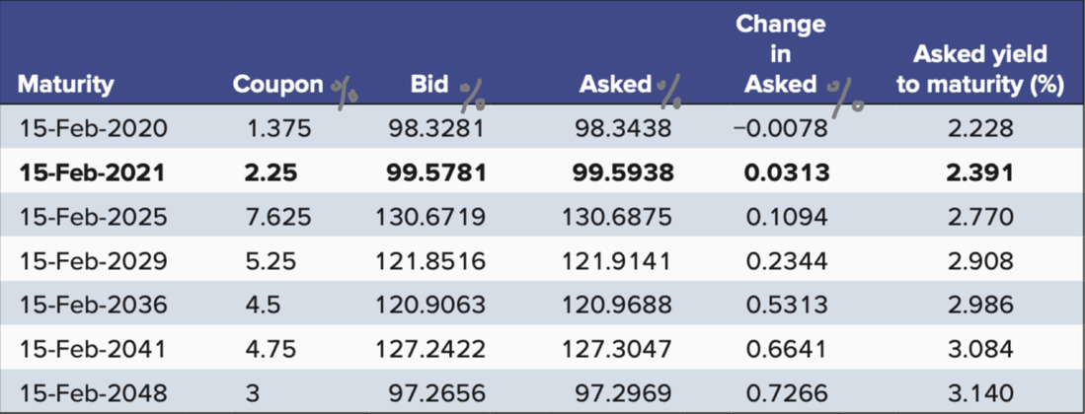

* **Face value:** 1000
* **Coupon:** x% of face value to be paid to the bondholder
* **Bid:** the selling price
* **Asked:** the buying price
* **Asked yield to maturity:** the rate of return if hold until maturity
* **Feature:** If the present value < face value: selling at a discount; present value > face value: selling at a premium

**Cash flow of buying a bond:**

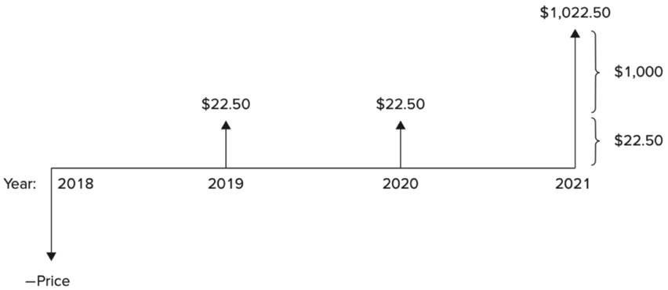

**Bond price and interest rate**

**Present value of the bond (which is also the bond price)**

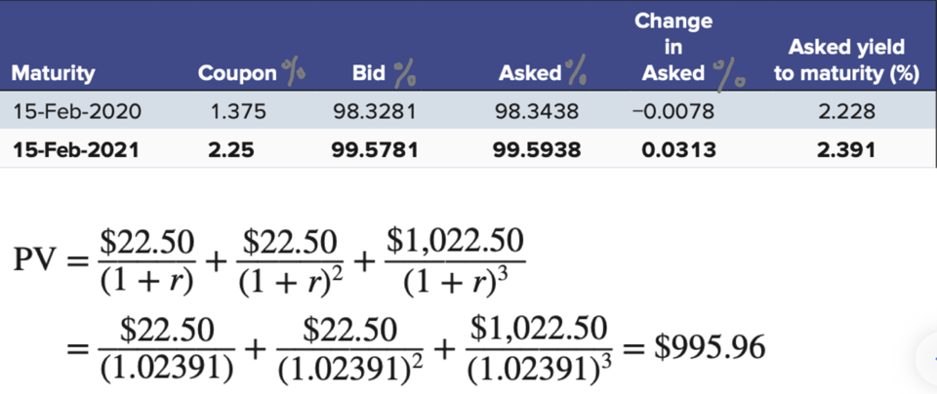

**Financial calculator**

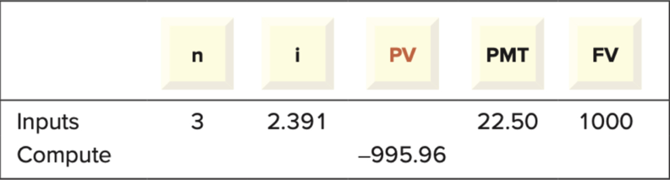

* Consists of PMT 22.5 and FV 1000 as the final payment

**Present value under semiannual coupon payments**

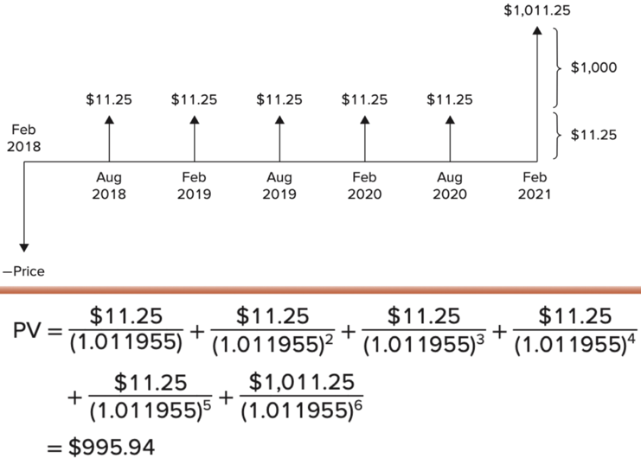

**Bond price with interest rate & coupon rate**

1. If market interest rate = coupon rate, bonds sell for its face value
2. If the market interest rate < coupon rate, bonds sell for more than face value
3. If the market interest rate > coupon rate, bonds sell for less than face value

**[Attention]:** the change of interest rate impacts present value of bond, but not the payments themselves.

**Interrelationship between bond price and interest rate**

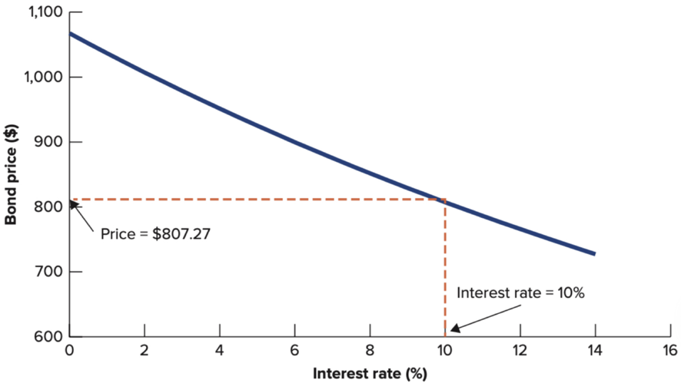

**Interrelationship between short-term and long-term bond**

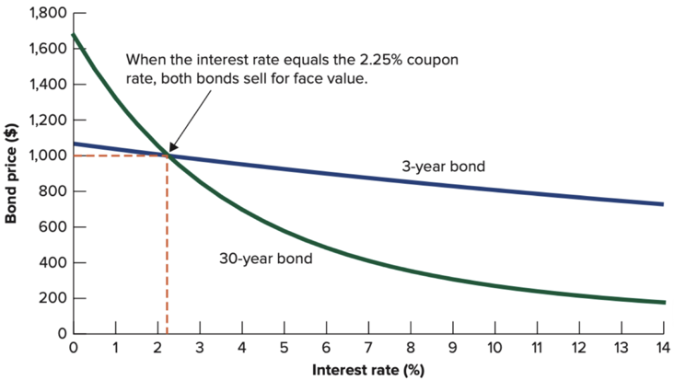

**Explanation:** if you buy 3-year and interest increases, then you only have to take a loss for several year, which is far less than 30 years.

**Yield to maturity**

(The **YTM** is merely a snapshot of the return on a bond)

**Current yield** (for bondholder) = $\frac{annual coupon payment}{bond price (asked price)}$ (ignores bond price changes (i.e. capital gain/loss), don't measure the total rate of return)

**Yield to maturity (anticipated value)**

Take account of both income and bond price change

**Definition1:** it's the discount rate which let the bond price = PV

**Definition2:** it's the rate of return every year if hold it to maturity

**Rate of return during a particular period**

**Rate of return** = coupon income / investment + price change / investment

**After buying the bond:**

* If interest rate decreases, bond price increases, then rate of return > YTM
* If interest rate increases, bond price decreases, then rate of return < YTM

**How bond price changes** yearly for (30-year bond, 4% yield to maturity)

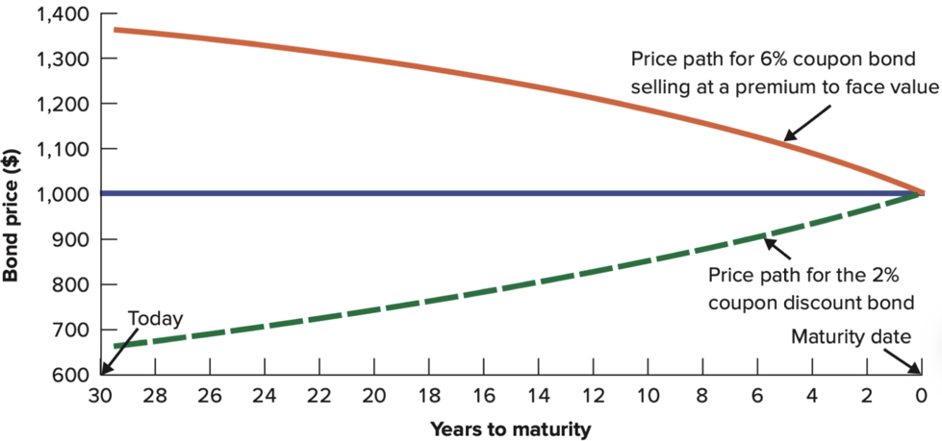

**Yield curve**

**Treasury strips:** the bonds do not have coupon payment and just have the final repayment.

**Yield curve:** relationship between (maturity time & YTM)

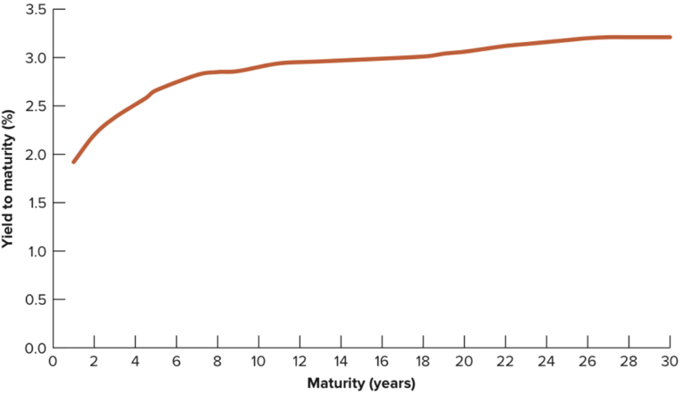

**Reasons** of not choosing long-term bonds

* Price fluctuates more violently
* More likely to profit from higher interest rate (sell, but rebuy in low price)

**Nominal and real interest rate**

$$real interest rate=\frac{1+nominal interest rate}{1+inflation rate}-1$$

**TIPS:** Treasury Inflation Protected Securities

If 3% coupon, 2-year TIPS, then real cash flow $30 per year, and final payment $1000

**Corporate bonds and the risk of default**

**Default risk/credit risk:** the risk that a bond issuer may default on

**Default premium:** yield on corporation bonds - yield on US Treasury bond (same coupon and maturity)

**Investment grade** (BBB and above) & **speculative grade/high yield/junk bonds** (below BBB)

**Protecting against default risk**

1. Seniority: hold senior claim (priority over other claims)
2. Security: a claim on assets or collateral
3. Protective covenants: limit the issuing of new bonds (debt in moderation is suitable for firms)

**2.3 valuing stocks**

**Stocks and the stock market**

**Common stock:** ownership shares in public held corporations

**Initial public (primary) offering** (IPO): first offering of shares to the public

**Primary market:** markets for the sale of new securities issued by corporations

**Secondary market:** markets where previously issued securities are traded among investors

**Limit order book:** record the bid and asked price from best to worst

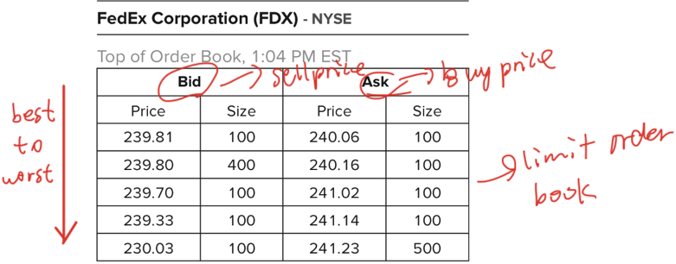

**Trading information**

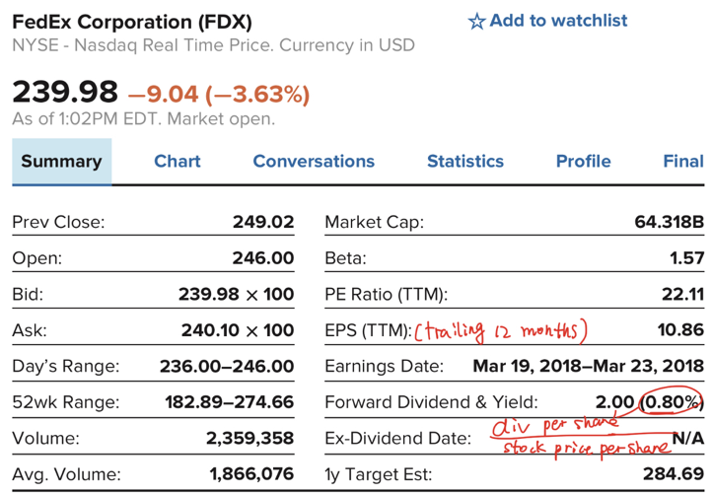

**Market values, book values, and liquidation values**

* **Book value (of equity):** the value in the firm's balance sheet
  + **Book value per share:** book value of equity / number of outstanding shares

* **Liquidation value:** the value of selling all assets - the money for paying off creditors

[not market values because successful company will value more than liquidation value]

* **Market value/market capitalization (going-concern value)**
  + Treat the firm as a going concern and has going-concern value
    - Extra earning power
    - Intangible assets
    - Values of future investments
  + Share price: market value / number of outstanding shares

**Growth stock:** stock of growing company (e.g. Amazon)

* Their market-to-book values are high because of their expected profitability on new investments

**Income stock:** stock of company that has constrained growth (e.g. Con Ed)

* Their market-to-book values are low because their values mostly depend on its existing assets

**Valuing common stocks**

**Market-to-book ratio:** market value / book value

**Price-earnings ratio (P/E ratio):** stock price (per share) / earnings (per share)

**Bond & stock:**

* Coupon payment each year + final payment of face value (specified)
* Dividend each year + final payment of stock price (not specified)

**Valuation by comparables**

Identify similar firms and compare the firm with these similar firms about market-to-book ratio and price-earnings-ratio.

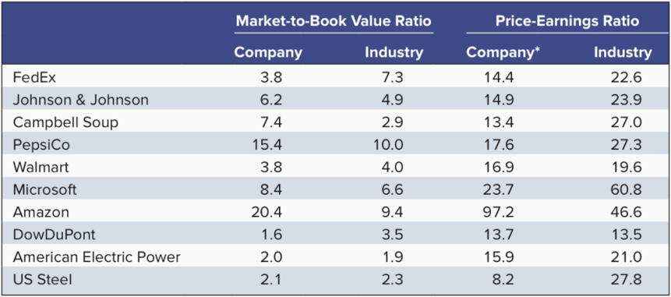

**Intrinsic value ($V_{0}$) $=PV=\frac{\left(DIV_{1} + P_{1}\right)}{\left(1 + r\right)}$ (for one-period)**

$P_{1}$: predicted stock price after 1 year

$DIV_{1}$: dividend after 1 year

$r$: discount rate (for a particular level of risk: higher risk, higher r)

**Definition:** PV of the cash payoffs anticipated by investors in the stock

**Expected return = $\frac{DIV_{1}+P_{1}-P_{0}}{P_{0}}=r$** (when stock at fair price i.e. Intrinsic value)

**The dividend discount model**

**Assumption:** the value of stock should have the same PV, even the time horizon is different (terminated price is determined by expected dividend: longer, more dividend, less terminated price)

* **With time horizon:**

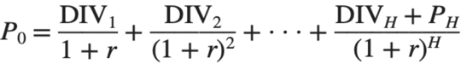

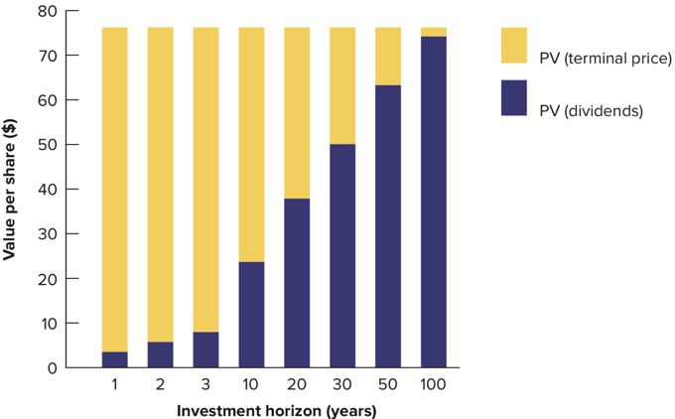

* **Without time horizon:**

$P_{0}=PV$ (no terminated price, all future dividends per share)

**Simplifying the dividend discount model**

**Case1 (perpetuity):** dividend with no growth (all earnings paid as the dividend)

**Assumption:** constant dividend $DIV_{1}$

$$P_{0}=\frac{DIV_{1}}{r}=\frac{EPS_{1}}{r}$$

**Case2 (Gordon growth model):** dividend with constant growth (g)

$$P_{0}=\frac{DIV_{1}}{1+r}+\frac{DIV_{1}(1+g)}{{\left(1+r\right)}^{2}}+\frac{DIV_{1}{\left(1+g\right)}^{2}}{{\left(1+r\right)}^{3}}+… \\ P_{0}=\frac{DIV_{1}}{r-g}=\frac{DIV_{0}*(1+g)}{r-g}$$

**Estimation of g**

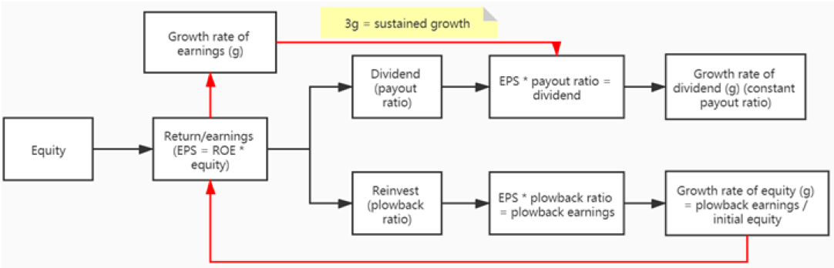

* Payout ratio: $\frac{paid-out as dividend}{total earnings}$
* Plowback ratio: $\frac{earnings retained in the firm}{total earnings}$

[payout ratio + plowback ratio = 1]

$$g=\frac{plowedback earnings}{initial equity}（1）$$

$$=\frac{plowedback earnings}{total earnings}(plowbacked ratio)*\frac{total earnings}{initial equity}(ROE)$$

1. Growth rate in book equity (g) = $\frac{plowedback earnings}{initial equity}$
2. If ROE is constant, then growth rate of earnings = growth rate in book equity = g

(EPS = ROE * book equity per share)

1. If payout ratio is constant, then increase rate of dividend = g

* Thus if ROE & payout ratio is constant, then growth of book value, earnings, dividend is the same, = sustainable growth rate

**Plowing back does not necessarily increase stock price:**

* The stock price of no-growth (g = 0) == the price of constant-growth when ROE = required rate of return (r) (g = ROE * plowback ratio)
* Only when ROE > r, then the value added.
* Firm performance $≠$ growth rate in EPS (book value of equity/share * ROE, ROE MUST > r)

**PVGO**

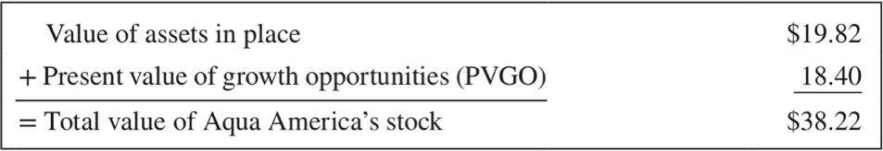

**PVGO:** PV of growth opportunities

Thus P/E ratio: indicator of growth opportunity (unless E is very small)

**Case3: with non-constant growth rate**

The growth is constant until year H

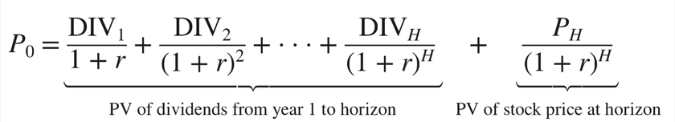

**DCF analysis and dividend discount model**

If business is public firm, and with no other assets and operations, all FCFs are paid as dividends, then dividend = FCFs / shares

Share price = market value of firm / total shares

**No free lunches on wall street**

**Random walk:** changes in stock price cannot be predicted from previous changes in stock price

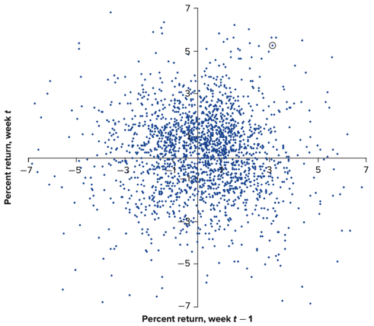

**Efficient market hypothesis:** the price has reflected all available information, thus the price is exactly the intrinsic value.

* **Weak form:** history prices are contained in the stock price (because random walk of price, it's impossible to make prediction)
* **Semi-strong form:** all public prices are contained in the stock price (history prices, annual reports etc.)
* **Strong form:** all public and private information are contained in the stock price.

**Behavioral finance**

* Attitudes towards risk
* Biases about probabilities
* Overconfidence
* Sentiment

**2.4 Investment appraisal**

**Net present value (NPV)**

**NPV** = $c_{0}+\frac{c_{1}}{(1+r)}+\frac{C_{2}}{{\left(1+r\right)}^{2}}+…+\frac{C_{t}}{{\left(1+r\right)}^{t}}$

* $C_{0}$: initial investment (money outflow)
* $r$: opportunity cost of capital (e.g. expected rate of return of investment alternatives)
* $C_{1},C_{2},…C_{t}$: money inflow every year (PMT)
* $t$: time period t of the investment

**Choose mutually exclusive projects**

**Mutual exclusive projects v.s. independent projects**

**Decision rule:** Any positive NPV if independent projects, highest NPV if mutually exclusive projects

**Situation 1:** investment timing ---- now or later?

**Decision rule:** choose the time of highest NPV

**Situation 2:** life of investment ---- long-lived or short-lived?

**Decision rule:** select the lowest EAA

**EAA (equivalent annual annuity/cost):**

$$=\frac{NPV (cost)}{annuity factor}$$

**Situation 3:** replacement ---- replaced or not?

**Decision rule:** if old operating cost > EEA (cost) of operating cost after replacement, then replace; otherwise, don’t replace.

**Pros and cons of NPV**

**Pros:** "golden standard" of investment, especially choose between mutually exclusive investments

**Cons:** do not consider capital rationing, because fund is infinite.

**Internal rate of return (IRR)**

**IRR:** the rate of return that leads to 0 NPV. (break-even project)

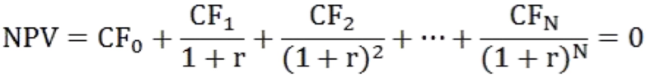

Thus discount rate (r) = IRR

**Decision rule:** r > IRR, NPV < 0, decline; r < IRR, NPV > 0, accept; higher IRR, higher priority.

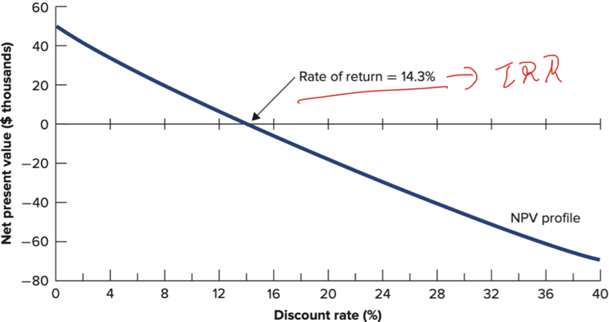

**Pitfalls with IRR**

* **Conflicts between IRR rule & NPV rule**

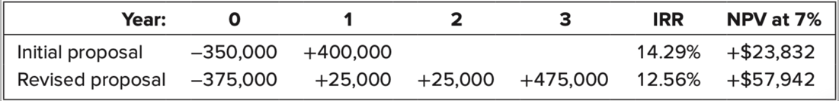

* **Multiple IRRs**

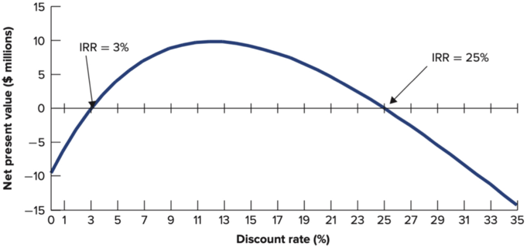

**Profitability index (PI)**

**Profitability index** = $\frac{NPV}{initial investment}$

**Decision rule:** higher PI

**Capital rationing (limits of fund for investment)**

**Soft rationing:** limit set by top management ---- extra sources and funds are available if top management allows

**Hard rationing:** limit set by capital market ---- no more extra funds both from both internal or external sources

**Pitfall with PI**

Not only the higher rate of return, the amount of return is also important

**Payback period rule**

**Payback period:** the length of time before the return covers the initial investment

* 1. If cash flow per period is equal

Payback period = initial investment / cash flow per year

* 1. If cash flow per period is not equal

Payback period A + B/C

A: the last period t when total cash flow < initial investment

B: initial investment - total cash flow at the last period t

C: the cash inflow of the (t+1) period

**Decision rule:** accept if payback return < the required period

**Pros and cons of payback period rule**

**Pros:** simple to understand and compute

**Cons:**

1. don't consider time value of money
2. If take this rule, then top management may cut off period to get money before they resign
3. Don't consider return after t period, thus the chosen project may not have the highest NPV

**2.5 Project analysis**

**Capital budgeting**

**Definition:** the process of analyzing or ranking all investment opportunities and deciding which ones to accept

**The aim:** ensure that the firm's investment matches its strategy, which reflects its competitive advantages

**Problems (& solutions) of capital budgeting**

1. Inconsistent assumption -> optimistic & pessimistic
2. Conflicts of interest -> agency problems
3. Forecast bias -> overstate the benefits of the project

**Variables influence the NPV**

**NPV** = investment + PV of cash flow from operations

**Sensitivity analysis (NPV varies when single variable changes)**

* **Variable costs:** cost changes depending on the sales/output
* **Fixed costs:** cost changes not depending on the sales/output

1. 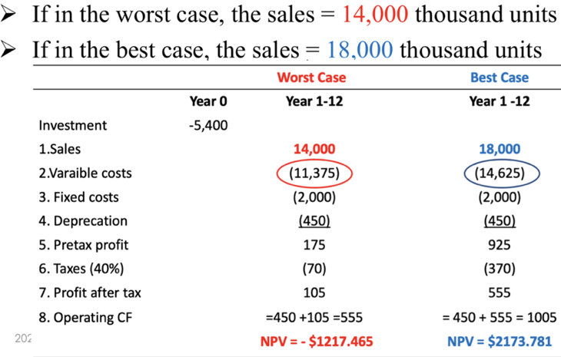**Possible changes in sales**
2. 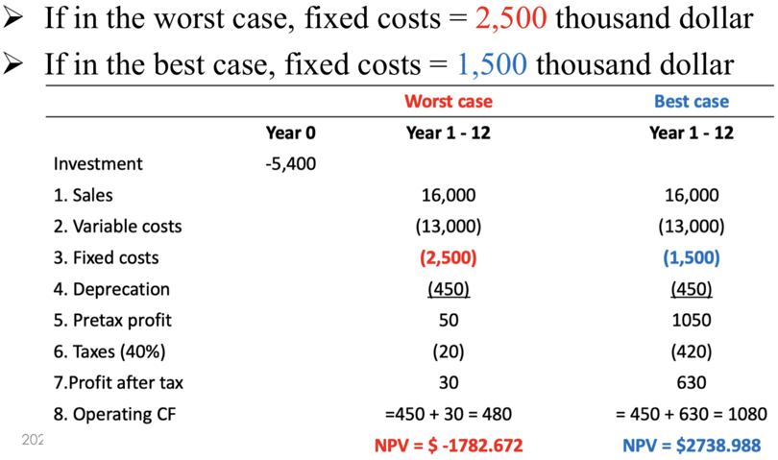**Possible changes in fixed costs**

**Limitations**

* No law of which variable will change
* Best/optimistic or worst/pessimistic cases are too subjective
* Changes are interrelated

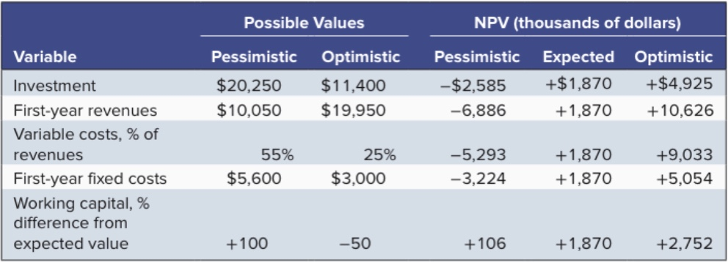

**Scenario analysis (NPV varies under particular scenario (i.e. combinations of variables change))**

* 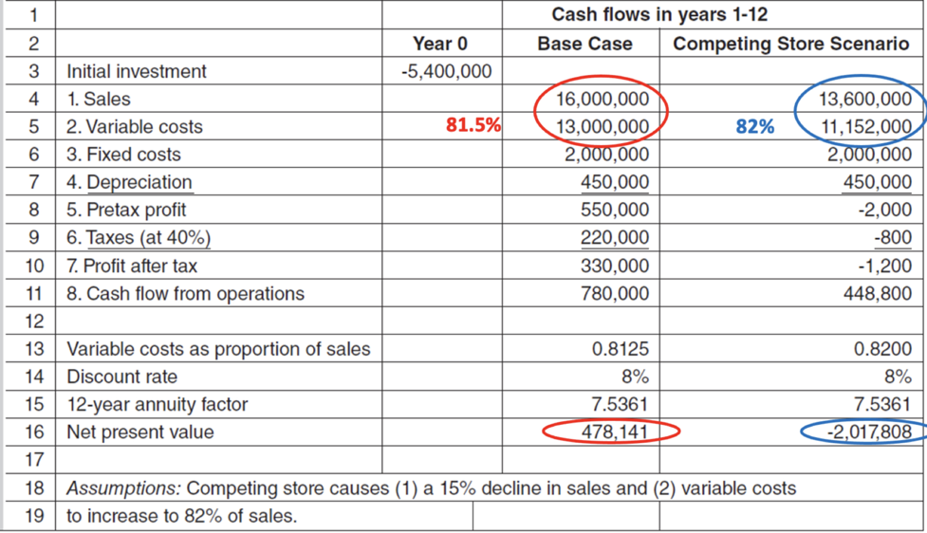**Possible changes in both percentage (cost/revenue) and sales**

**Accounting break-even analysis**

**Definition:** the number of sales makes the profit 0

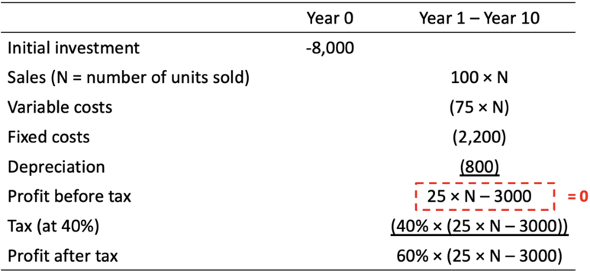

**Analysis**

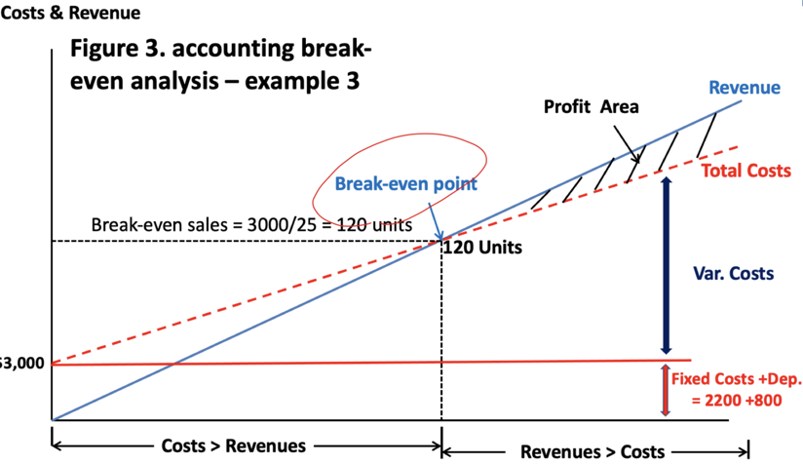

**Calculations for break-even revenues**

Break-even revenue = break-even units sold * price per unit = $\frac{fixed cost + depreciation}{profit from additional dollar sold}$

**Limitations:** no time value of money (i.e. NPV may be negative if taken into account of original investment)

**NPV break-even analysis**

**Definition:** the level of sales for which NPV = 0

NPV = investment + PV of cashflow from operations = 0

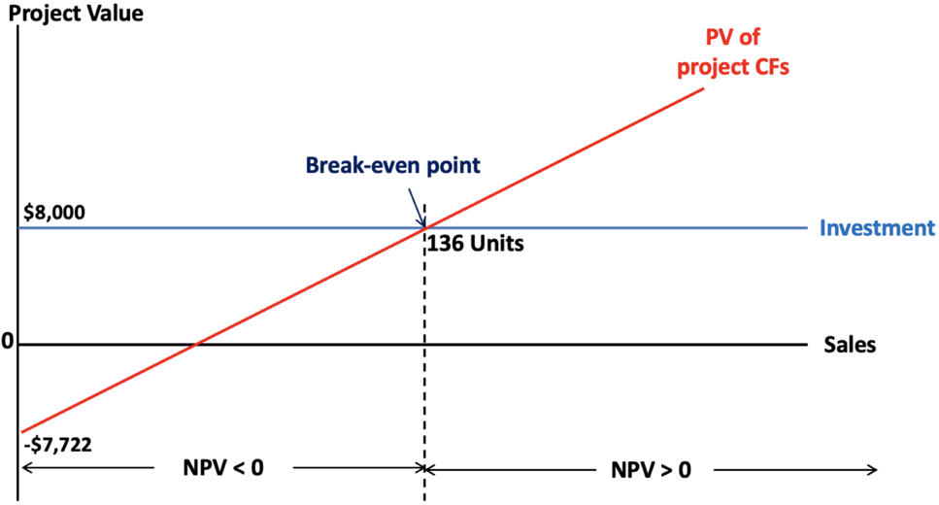 **Analysis**

**[Attention]:** higher cost for NPV break-even because cost of time value of money has been taken into account.

**3 Risk**

**3.1 Risk & return**

**Capital market history**

**Market indexes:** standard & Poor's 500, Dow Jones Industrial Average

**Maturity premium:** annual return of long-term treasury bills - annual return of short-term treasury bills

**Risk premium** = rate of return of small stock - rate of return on short-term treasury bills

**(Market risk premium)** = rate of return of market portfolio - rate of return of short-term treasury bills

**Historical records:** risky assets have risk premium, high-risk assets have higher average return than low-risk assets

**Measuring risk**

**Distribution of average rate of return**

* 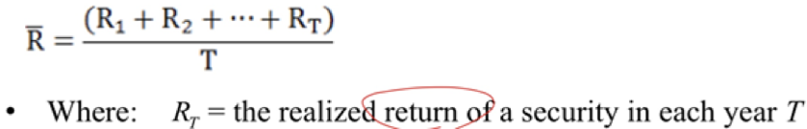**Average annual return** (mean)
* 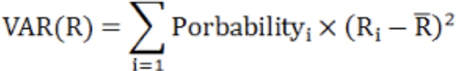**Variance:** higher variance, higher risk
* **Standard deviation** (SD): $SD\left(R\right)=sqrt(VAR\left(R\right))$

**Risk and diversification**

**Portfolio diversification**

Portfolio rate of return = (fraction of portfolio on nth asset * average rate of return on nth assets)

**Investment opportunity frontier**

**Relationship between SD & rate of return for various weights**

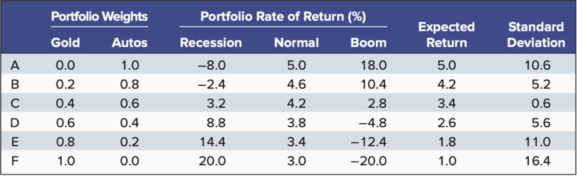

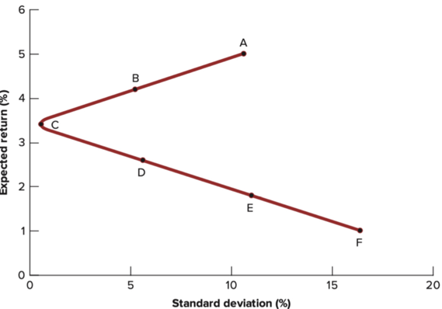

* More negatively related assets are beneficial to the portfolios. (ice cream and umbrella)

**Risks**

* **Market risk/systematic risks:** risk that affects the overall stock market
* **Specific risk/diversifiable risks:** risks have no relation with others

* Market risk is unavoidable but specific risk can be eliminated by well-functioning portfolios

**3.2 CAPM and WACC**

**Measuring market risk (beta)**

**Market portfolio**

* Diversified portfolio of common stocks (e.g. S&P 500)
* Market risk cannot be eliminated by diversifications

**Beta (market risk)**

**Definition:** risk of individual securities measured by the responsiveness to the risk of market portfolio

β is the slope of the line that the (market return, individual return) fits in.

**Situations:**

* If β < 1, then individual securities are less volatile than market portfolios;
* If β = 1, the same
* If β > 1, then individual securities are more volatile than market portfolios

**Portfolio beta**

Portfolio beta = (fraction of investment in stock A $β_{A}$* ) + (fraction of investment in stock B $β_{B}$* ) +…+ (fraction of stock N $β_{N}$* )

**The capital asset pricing model (CAPM)**

**Assumption:** only market risk affects expected return (specific risks have been eliminated)

**Expected return** [for any asset] = risk-free rate of return to compensate for inflation and time value of money (e.g. treasury bills) + risk premium (depends on beta and market risk premium)

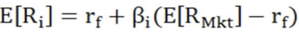

**Security market line (SML)/CAPM:** relationship with expected rate of return and $β_{i}$

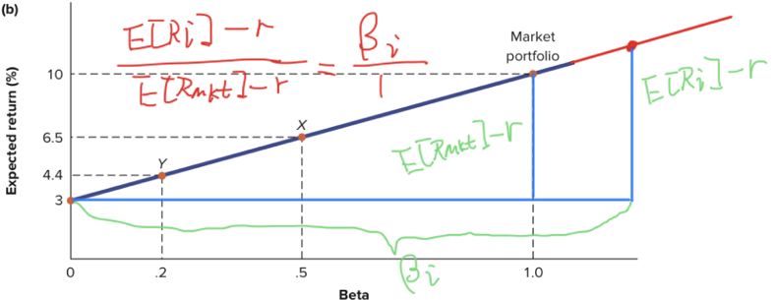

**SML for choosing projects:** if expected rate of return of projects is above SML, then we can accept this project (same beta, higher rate of return)

**Weighted average cost of capital (WACC)**

**The firm's capital structure**

**Capital:** source of finance - debt, equity and other outstanding securities

**Capital structure:** relative proportion of debt, equity and other securities a firm holding.

**Weighted average cost of capital (WACC)**

Average firm's equity, debt costs of capital according to their respective market values (because investors pay for market value)

**Unlevered: $r_{WACC}$**

**Levered: $r_{WACC}$**  = fraction * cost of equity + fraction * cost of debts

1. **Cost of debt capital**
   * **Definition:** YTM
   * **Effective cost of debt: $r_{D}(1-T_{c})$**

1. 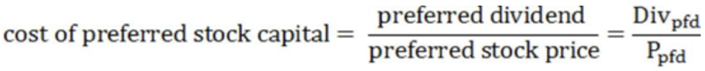**Cost of preferred stock capital (no growth)**
2. **Cost of common capital (equity)**
   1. For constant-growth dividend discount model

* 1. CAPM:

**Difference between method(i) & method(ii)**

**Reason:** different inputs and major assumptions

**WACC pitfalls**

1. The use of WACC is appropriate for projects that have the same risk as the firm's existing businesses
2. We can adjust benchmark (discount rate) upwards or downwards for risker or safer projects

**Value a business/project by discount cash flow/WACC**

**Free cash flow (FCF) =** Operating cash flow + interest payment - investment expenditures (which is value that the business can give its investor)

**[Valuation horizon]:** H

$$PV_{firm}=\frac{FCF_{1}}{(1+WACC)}+\frac{FCF_{2}}{{\left(1+WACC\right)}^{2}}+…+\frac{FCF_{H}}{{\left(1+WACC\right)}^{H}}+\frac{PV_{H}}{{\left(1+WACC\right)}^{H}}$$

$$PV_{H}=\frac{FCF in year_{H+1}}{WACC-g}$$

g: asset growth rate, is the growth rate of FCFs, and growth rate of assets value

**4 Corporate financing**

**4.1 Raising equity**

**Source of corporate financing**

**Source of funds**

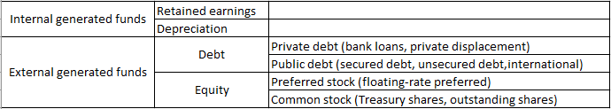

* **Preferred stock:** preference in payment of dividends and liquidation, no voting rights, fixed dividend paid
  + **Floating-rate preferred:** the dividend rate links to the interest rate, thus when r increases, dividend rate increases, thus protect the stockholder.

* **Common stock:** voting rights
  + Treasury shares (internal shares, held in company's treasury, issued but not understanding)
  + Outstanding shares (external shares, held by investors, issued but outstanding)

**Concepts**

* **Long-term financing:** long-term debt + equity
* **Net worth:** Book value of (common stock + preferred stock)
* **Financial deficit:** cash company needs - the amount generated internally
* **Authorized share capital:** the maximum number of shares that the company is permitted to issue.

**Shareholder's equity:**

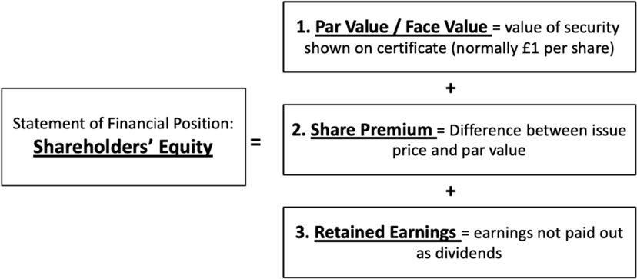

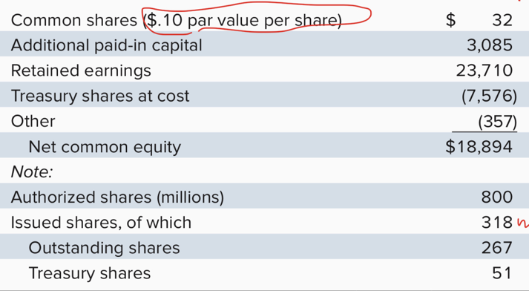

* Additional paid-in capital: (share price - par value) * issued shares
* Treasury shares: issued but not outstanding
* Outstanding shares: issued but outstanding

**Equity financing for private firms**

**Potential sources**

1. **Angel investors:** wealthy, individual investors, buy equity of private firms
2. **Venture capital firms:** 
   * Specialize in raising money to invest in equity of private young company
   * Often demand control of company
3. **Institutional investors:**
   * Pension fund, insurance companies
     + Directly
     + Indirectly (by being LP of VC firms)
4. **Corporate investors:**
   * Established corporations purchase equity in young firms (Tencent)
     + Corporate strategic objective
     + Aim for investment return

**Securities and valuation**

**When first issued:** preferred stock > common stock

* **[Convertible preferred stock]:** owner has the option to convert into common stock at a future date.
* **Pre-money valuation:** valuation of firms before an investment
* **Post-money valuation:** valuation of firms after an investment

**Exit strategies for investment**

* Acquisition
* Public offering

**The initial public offering (IPO)**

**Definition:** process of first time selling stock to the public

**Pros and cons of going public**

* **Pros:** greater liquidity, better access to capital
* **Cons:** dispersed equity holders, satisfy public companies' requirement

**IPO offers**

* **Primary offers:** new shares available when issuing
* **Secondary offers:** equity offering of shares by existing shareholders (exit strategy)

**Underwriter & syndicate**

**Underwriter:** an IB firm manages the offering and design its structure

**Syndicate:** a group of underwriters

**Lead underwriter:** primary banking responsible for managing the IPO

**SEC filings**

**Registration statements:** legal doc provides financial and other information about a firm

* Preliminary prospectus
* Final prospectus

**Valuation**

**Book-building:** the process by underwriters for producing offer price based on customer's interest.

**Road show:** firm's management and lead underwriter travel to promote the firm & explain the rationale for the offering price to institutional investors.

**Payoff of the deal and managing risk**

**Spread:** deduct a percentage of issue price (e.g. 5%)

**Lockup:** a restriction preventing shareholders selling their shares within 180 days after IPO.

**Firm commitment IPO:** the underwriter guarantees that all stocks will be sold at offer price

**Best-effort basis:** underwriter does not guarantee but try to sell at the best possible price

**Dutch auction IPO:** institutional investors auction off the shares, let the market deciding the offer price (the last success auction price = offer price)

**Relationship between underwriters, investors, firms**

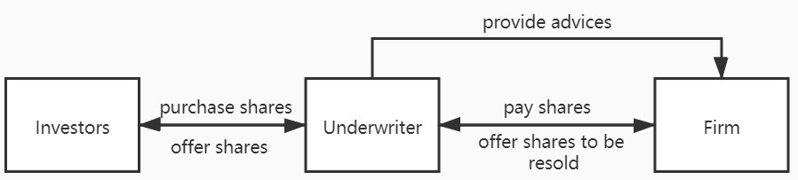

**IPO puzzles**

* **Under-pricing of IPOs**
* **High issuing costs of IPO:** commission to underwriter is high

**Raising additional capital: the seasonal equity offering (SEO)**

**Definition:** firms return to the equity market to offer new shares

* **General cash offer:** issue open to the public
* **Rights offer:** issue only to current shareholders at a discount

**SEO process**

The main difference between (IPO & SEO) is that price-setting is unnecessary for SEO

**SEO price reaction**

**Phenomena:** on average, SEO will face price decline after issuing

1. Firms which do not have enough retained earnings will look for funds, this is a bad signal to the market.
2. This means stocks are overpriced, they want to continue making profits, which is a bad signal to the market.

**4.1 Raising debt**

**Corporate debt**

**Private debt** (debt not publicly traded)

1. **Bank loans**
   * Term loan (offered by single bank)
   * Syndicated bank loan (offered by a group of banks)
   * credit line (e.g. credit card)
2. **Private placement:** not trade on market but directly to small groups of investors

**Public debt** (can be publicly traded)

1. **Secured corporate debt** (bondholder can directly claim to assets)
   * **Mortgage bonds:** house etc.
   * **Assets-backed bonds:** inventories, machinery etc.

1. **Unsecured corporate debt** (bondholder claim limited to unpledged assets)

**Public debt in international markets**

1. **Domestic bonds**
   * Issuer: local entity
   * Trade place: local market
   * Denomination: local currency

1. **Foreign bonds**
   * Issuer: foreign company
   * Trade place: local market
   * Denomination: local currency
2. **Euro bonds**
   * Issuer: foreign company
   * Trade place: local market
   * Denomination: not local currency

**\*Foreign bonds**

* Yankee bonds (issued in US)
* Samurai bonds (Japan)
* Bulldogs bonds (UK)
* Panda bonds (China)

**Bond covenants**

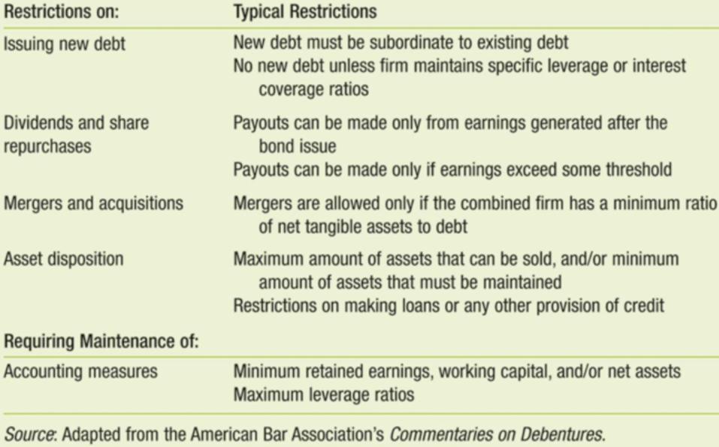**Advantage:** covenants reduce its costs of borrowing, this may outweigh the cost of loss of flexibility associated with covenants

**Repayment provisions**

1. **Call provisions**

**Definition:** clauses in bond agreement allow the issuer the right to repurchase and retire bonds.

**Callable bond (issuer -> call bond)**

* **Call date:** the date when issuer can retire the bond (from the earliest to latest)
* **Call price:** a price that issuer can redeem (coupon + face value)
* **Call premium:** the difference between call price and the face value

1. **Yield to call (YTC)**

**Definition:** the yield of a callable bond under the assumption that bond will be called at the earliest call date

1. **Yield to worst**

**Definition:** min{YTC, TYM}

If YTC > YTM, the issuer will not call the bond.

1. **Convertible provisions (bondholder -> convert bond)**

**Convertible bonds:** corporate bonds give bondholder an option to convert each bond into a fixed number of common shares

**Conversion ratio:** x shares/bond

**Conversion price:** x money/share

**Warrant:** right to buy company's shares at a stipulated price before a set date.

**Convertible bonds** similar to (bonds + warrants), but convertible bonds do not need to pay money, just convert

**5 Debt and payout policy**

**5.1 Debt policy: capital structure (long-time financing)**

**How borrowing affects value in perfect market**

**Perfect capital market:**

* Securities are fairly priced
* No tax, transaction costs
* Investment cash flow are independent of financing decisions

**Value of firm**

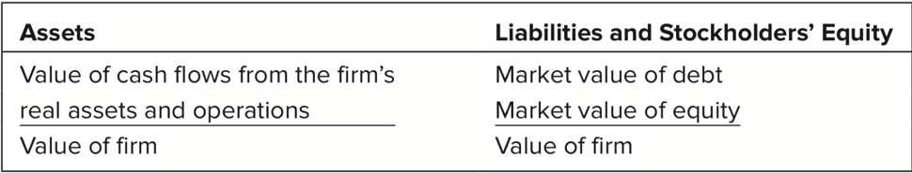

* Firm's market value is determined by the cash flow by real assets and operations
* Also market value [debt + equity] = market value of firm
* Cost of capital (firm) = rate of return (investor) = discount rate

**MM proposition 1 (debt-irrelevance)**

In perfect market, the value of firm is not influenced by the capital structure

$$(V_{L}=E+D=V_{U})$$

**[Restructuring]**

Change capital structure without changing capital structure (money issued by debt directly used to repurchase debt rather than staying)

**How borrowing affects return on shares (EPS)?**

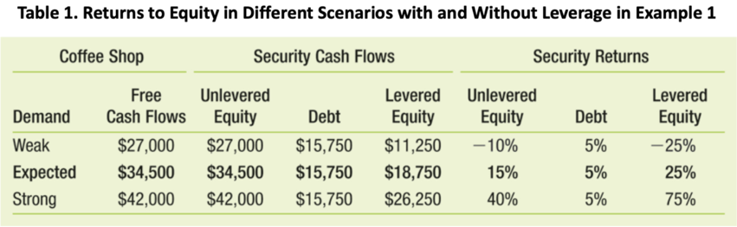

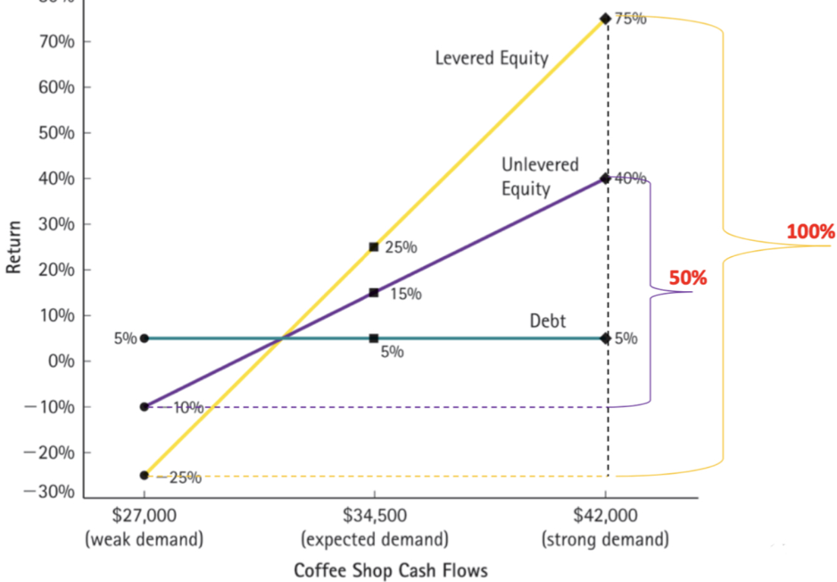

* Higher rate of return or higher rate of loss for levered equity

**How borrowing affect risk and return?**

Debt finance doesn't affect business risk/operating risk (i.e. operating income), but does affect financial risk: less equity to absorb the same amount of operating risk, if more debt finance.

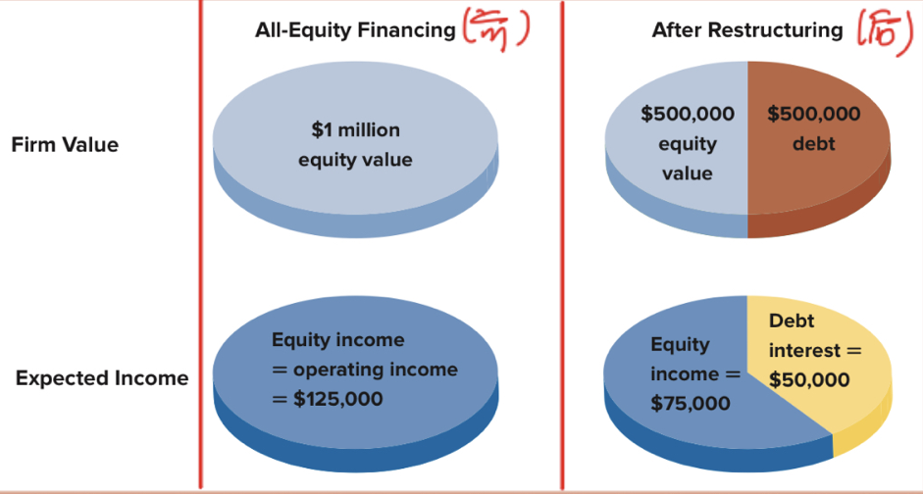

**Debt (D) and cost of equity ($r_{E}$) (perfect market)**

$r_{asset}=r_{debt}*\frac{D}{D+E}+r_{equity}*\frac{E}{D+E}$ (all market values)

[Not $r_{WACC}$ because ignoring taxes]

**Cost of capital:** the return is you buy all debts and equity of the firm

[ $r_{asset}$ is unchanged, because operating income is not changed]

**MM proposition 2**

**Cost of equity: $r_{E}=r_{U}+\frac{D}{E}(r_{U}-r_{D})$**  (higher leverage increases financial risk)

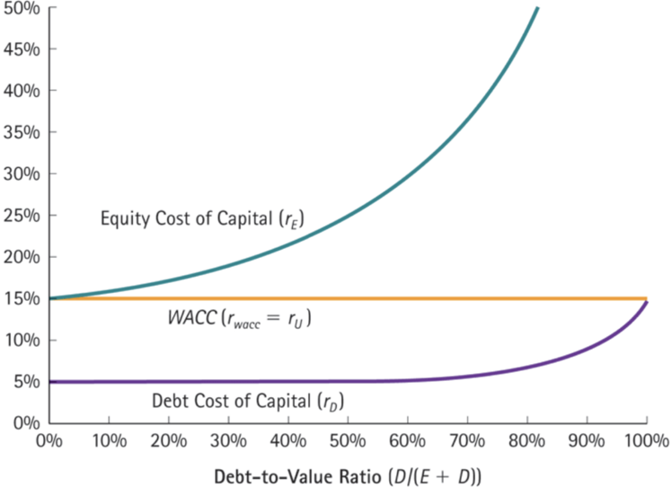

**Debt, taxes and WACC (imperfect market)**

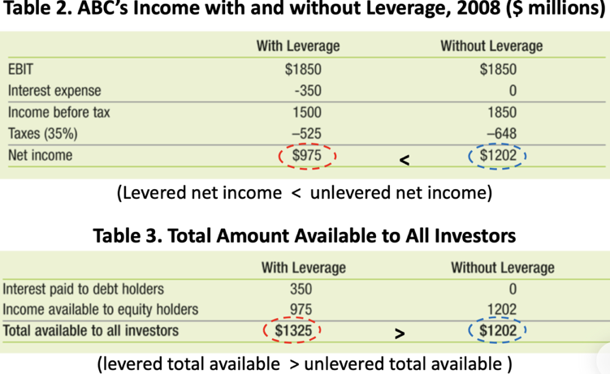

**Interest tax shield**

* Interest tax shield = interest expense * tax rate
* CF with levered equity = CF with unlevered equity + interest tax shield

**MM1 with taxes (modified)**

$$V_{L}=V_{U}+PV(interest tax shield)$$

[Because every year's earnings will be more tax yield shield, thus PV of tax shield is the difference of market value]

**Taxes and WACC**

Usually no firms calculate PV of tax shield, they calculate WACC:

$$r_{WACC}={\left(1-T_{c}\right)*r}_{debt}*\frac{D}{D+E}+r_{equity}*\frac{E}{D+E}$$

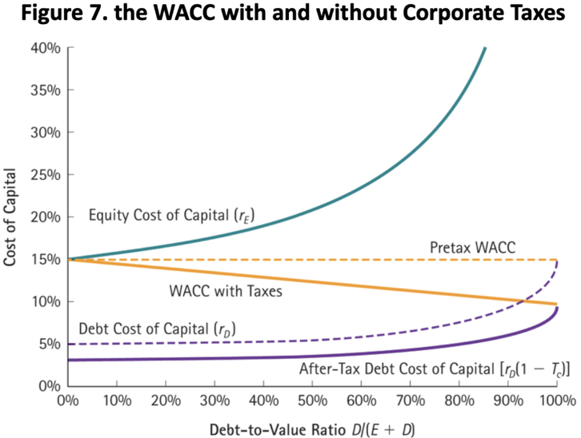

* Lower WACC because higher market value of the firm

**Costs of financial distress (imperfect market)**

$V_{L}=V_{U}+PV\left(interest tax shield\right)-PV\left(financial distress costs\right)$

$$[PV\left(financial distress costs\right)=probability of bankruptcy * cost$$

$$of bankruptcy]$$

**Direct costs:** (total 3% - 4% of pre-bankruptcy market assets)

* Time-consuming
* Creditors often wait several years to receive payment
* Outside professionals are generally hired

**Indirect costs** (10% - 20% of firm's value)

* Loss of consumers
* Loss of suppliers
* Loss of employees

**Financing choices**

**The tradeoff theory**

**Optimal debt choice:** marginal increase of tax shield = marginal increase of financial cost

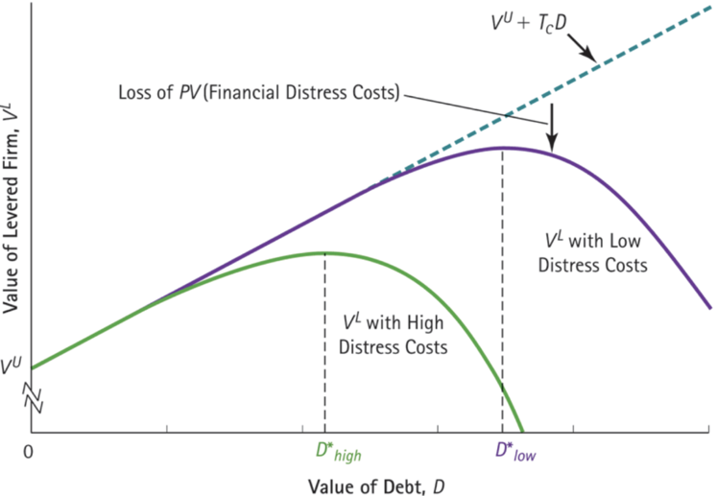

**The pecking order theory**

**For firm:** retained earnings > debt > equity

[Only firm who have significant debt financing will issue equity]

**5.2 Payout policy**

**How corporation pay out cash to shareholders?**

**Payout policy**

1. Cash dividends
2. Repurchase shares

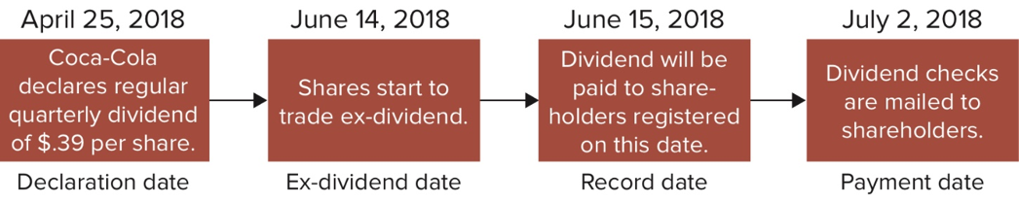**Dividend payout**

**[ex-dividend]:** buyers on or after that date will not receive the dividend

**Stock dividends and splits (NOT cash dividend)**

**Stock dividend:** issue additional shares to its shareholders

**Stock split:** stock dividends of 50% or higher

* **10% stock dividend:** one new share for every 10 shares already owned
* **3-for-2 stock split:** = 50% shock dividend, 1 additional share for every two shares

**Features**

* Total market value is unchanged
* Number of shares outstanding increases
* Thus stock price will fall
* Stock dividend will not be taxed

**Motivation**

* Keep share price in a range to attract small investors
* Increase demand, increase liquidity, boost share price

**Repurchase shares**

1. Open market repurchase
2. Tender offer (state as a fixed price and when enough, then deal is done)
3. Auction
4. Targeted repurchase / direct negotiation (negotiation with major shareholders)

**The information content of dividends and repurchases**

**Asymmetric information:** managers' payout decisions reflect the future prospect of the firm

**Dividend information**

**Features**

1. **Dividend smoothing:** maintaining relative constant dividend - increase only when sustainable growth of future earnings, decrease only as a last resort
2. **Changes:** mangers focus on changes of dividends rather than the absolute value of dividends

**Signaling**

* **Increase of dividend:** signal of good news; lack of investment opportunities
* **Decrease of dividend:** signal of bad news; exploit positive NPV investment opportunities

**Stock repurchases information**

**Signaling**

1. **Increase of shock repurchase:**

* The stocks are underpriced
* The firm may cannot deal with the cash

**Payout controversy (dividend or repurchase)**

**Capital budgeting & borrowing decisions**

|  |  |  |  |
| --- | --- | --- | --- |
| **Capital budgeting** | low dividend | cash -> investment |  |
| **Borrowing decisions** | high dividend | borrowing -> investment | cash -> payout dividend |

**Controversy (Given capital budgeting and borrowing decisions)**

* Dividend increases value
* Dividend decreases value
* No effect of value

**No effect on firm's value in perfect market (different payout policies)**

**Policy 1: pay by dividend**

* Value of firm (cum-dividend) = current dividend + PV (future FCF)

Share price = cash/shares + FCF/(discount rate*shares)

* Value of firm (ex-dividend) = PV (future FCF)

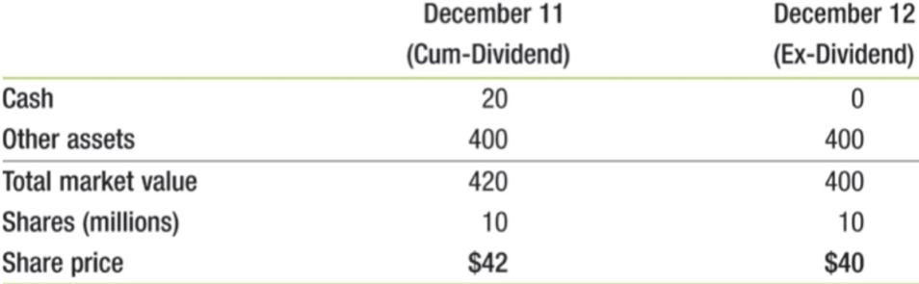Share price = market value of firm / shares

**Policy 2: pay by share repurchase**

* Value of firm (before repurchase) =PV(future FCF)

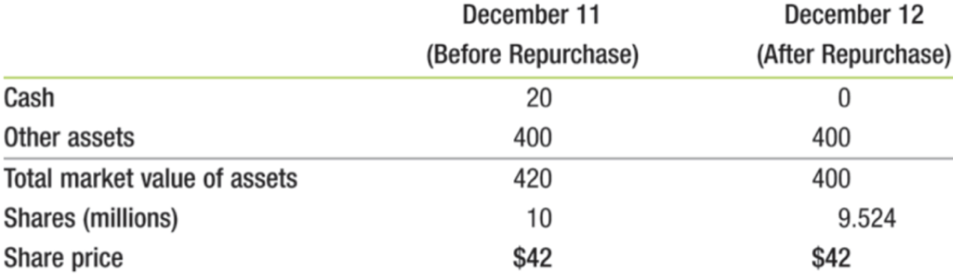Share price = market value of firm / shares

Repurchase does not influence share price

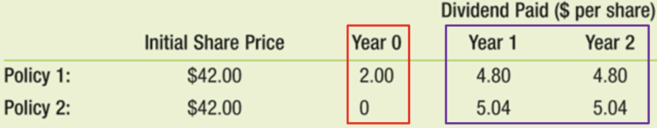**Tradeoff between 2 policies**

More dividend now means less future dividend growth, less dividend means more future dividend growth

**MM and dividend policy irrelevance and perfect market**

Higher FCFs means higher payout and determines higher price. But the firm's choice of dividend policy in a perfect market does not affect initial share price.

**The tax disadvantage of dividends (shareholders 角度)**

**Tax on:**

* Dividends shareholders receive
* Capital gains when they sell shares

**Tradeoff between dividend & capital gain**

* If div_taxrate > CG_taxrate, then more tax if choosing dividend
* Some people will pay dividend because of some policy (e.g. only 50% of dividend will be taxed)
* Even div_taxrate = CG_taxrate, div should pay immediately, but capital gain can be delayed, thus having advantages of time value of money.

**Optimal dividend policy**

* 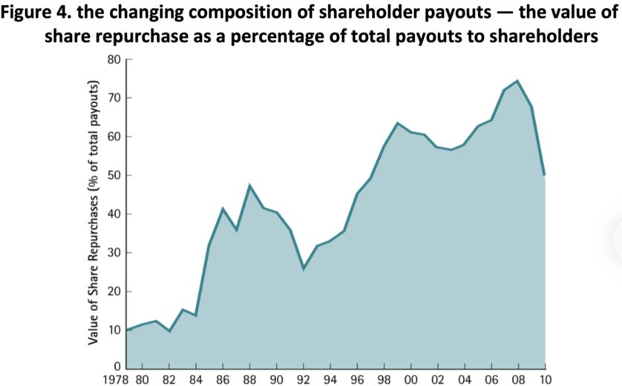When div_taxrate > CG_taxrate, no dividend

[Higher proportion of repurchases means higher taxes on dividend.]

**Clientele effect**

**Definition:** the dividend policy reflects the tax preferences of its clientele

* Individuals in the highest tax brackets may pay less or no dividend
* Tax-free investors have no preference to dividend or no-dividend, sometimes may prefer dividend
* Dividend policy is optimal for the tax preference of investors

**Payout policy & retention of cash policy (payout & retention)**

**Perfect market:**

Retention & payout not influence the initial value of the firm

**Imperfect market:**

Cash can be negative leverage and thus a disadvantage of holding cash because tax advantage of leverage

**Retaining cash with imperfect capital markets**

* Retaining cash may have tax disadvantage
* Cash is important to cover potential future cash shortfalls or periods of operating losses because of financial distress

**6 Financial analysis and planning**

**6.1 Working capital management**

**Short-term financial planning**

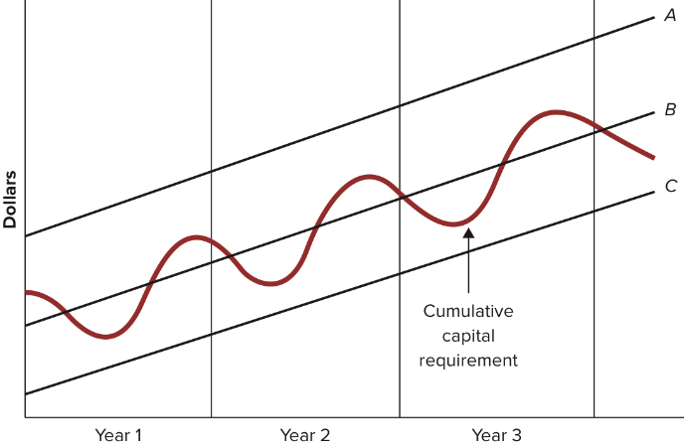

**A,B,C** - long-term financing planning; **red line** - cumulative capital requirement

Short-term financing planning = long-term financing planning - cumulative capital requirement

**Strategies**

A: relaxed strategy, permanent cash surplus

B: middle-of-the-road policy, seasonal fluctuations, temporary cash surplus or deficit

C: restrictive strategy, short-term financing, permanent cash deficit

**Borrowers & lenders**

A: lenders

B: borrowers or lenders

C: borrowers

**Best strategy** (combination of short-term financing + long-term financing)

* **Matching maturities:** short maturity for short-term debt, long maturity for long-term debt
* **Permanent working capital requirement:** fixed working capital, minimum for working capital needed, without which the business cannot survive (permanent investment in net working capital, financed by long-term sources (e.g. equity)
* **Maintaining liquidity:** keep current assets that can be quickly converted into cash

**Overview of working capital**

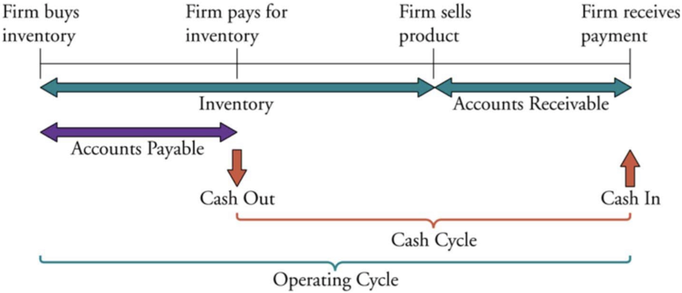

Cash cycle/cash conversion cycle = inventory days + accounts receivables - accounts payables

* Inventory days = inventory / (annual cost of goods sold / 365)
* Accounts receivables days = accounts receivables / (annual sales / 365)
* Accounts payables days = accounts payables / (annual cost of goods / 365)

**Tracking changes in cash and working capital**

**Cash budgeting**

**Definition:** forecast cash inflows or outflows on certain period to identify potential cash shortfalls

**Steps:** identify source of cash -> identify use of cash -> calculate cash shortage or surplus

**Cash raising sources**

* Issue new bonds/shares
* Bank loan
* Selling (reducing inventory level)
* Getting cash (reducing receivables)
* Business operations (selling products/services)

**Cashing spending sources**

* Dividend payment, tax, interest
* Repaying bank loan
* Purchasing inventories/raw materials
* Repay money (reduce accounts payables)
* Investing in fixed assets, working capital, financial assets

**Working capital management**

**Trade credit:** credit firms extend to its customers

**Trade credit terms:** 2/10, net 30

**Discount period:** 10 days

**Cash discount:** 2% cash discount is taken if paid by during the discount period

**Credit period:** 30 days, total length of time credit is extended to buyer

**Cost of trade credit**

Effective annual rate = ${\left(1+\frac{discount}{discount price}\right)}^{\frac{365}{extra days}}-1$

(98 → 100 in (30 - 10) days, thus (100-98)/98 = discount/discount price)

**[Solution]:** if necessary and EAR > common r, then it would be better if firm first borrows money from bank to repay before date, then finds methods to repay to the bank.

**Receivables management (credit analysis)**

* Credit agencies provide reports on credit worthiness
* Check with customer's bank
* Calculate financial ratios

**Inventory management (holding inventories)**

**Benefits:**

* Minimize risks of not being able to obtain inputs for production
* Avoid temporarily order
* Reduce order costs

**Costs:**

* Acquisition costs
* Carrying costs - storage costs, insurance, OC of funds on inventories

